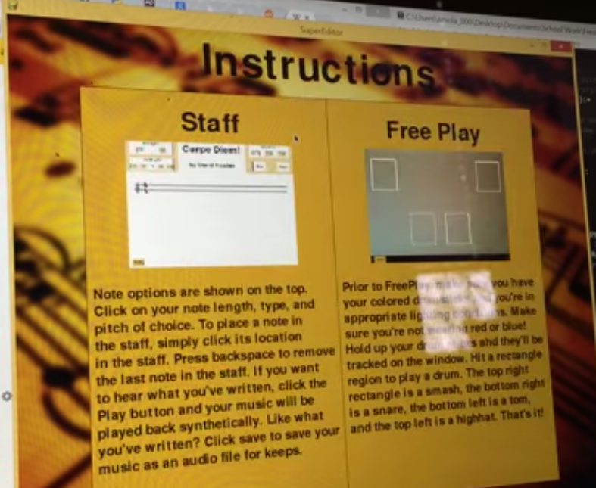
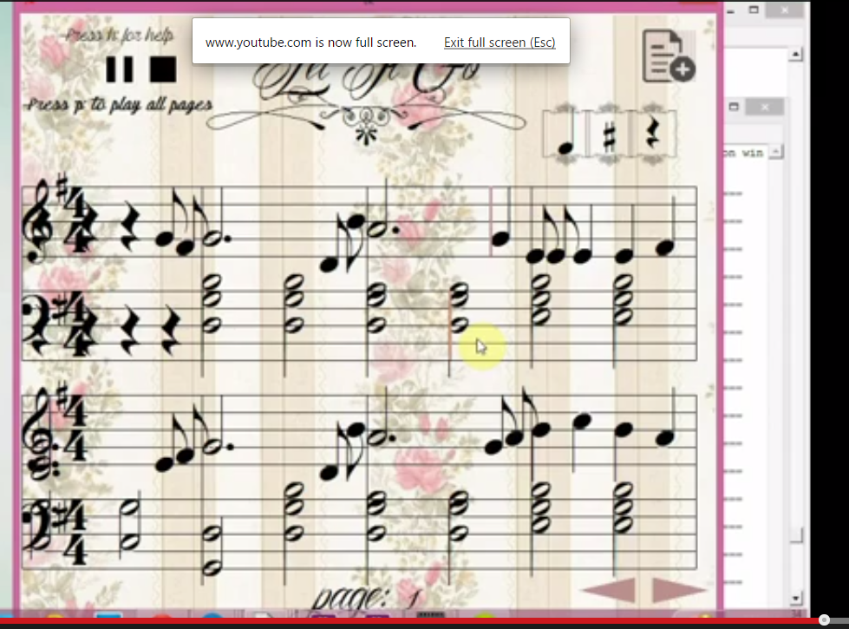
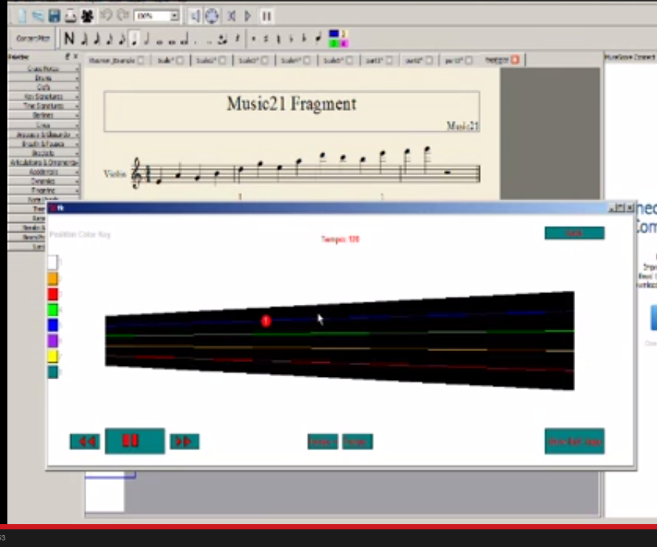
Akash Kejriwal
15-112 Section H
Term Project Deliverable 3
Competitive Analysis / Design Ideas

When I began researching ideas for my term project, I came up with three ideas and approached David Kosbie and asked his thoughts on which project is most feasible dependent on complexity. Following the discussion, I solidified my term project idea. However, I didn’t research any of the modules that could be used to help me solve this project until five days ago.
While scouring the web and discussion with peers, I came across three projects that had similarity to the idea I had in creating this project.
The first project I viewed, Air Drum Music Editor, by Amolak Nagi, gave me the idea of having two different options for my term project. In his project, he had two options: create your own and have the sheet music play or have the music play through the use of OpenCv and a webcam. I also liked how he represented his staff in his project.
The second project I viewed, Fun With Music!, by Abhy Vytheeswaran, implemented the idea of drawing your own notes on a staff and having to animate the music. However, in her project, she had more than one bar which led to the idea of the wraparound and having some form of a counter that would highlight the current note that was being played.
Finally, the third project I viewed, Violin Cheat Sheet, by Christine Amin, is almost an identical project to mine. She animations the violin fingerboard and does by having the user choose which notes the user wants to play on a staff. Then, she can indicate what fingering positions the user wants to use. To continue with my project, I scheduled a meeting with Christine and met up for approximately twenty minutes. In this time, Christine gave me advice on what the best module is to use for this type of project, music21. So far, this module has been key in implementing my project and I can’t thank her enough for recommending this module.

While I liked some of the features from the three projects I researched, I would still like to exhibit originality. The list of features I plan on using from each project:
- Project 1:
  - Versatility. Being able to write your own score and then have the program animate and play it.
  - In his program, I also like how he chooses notes and gives options of varying length.
  - Unique to his program: no one designates the loudness of the note. He adds an option from low, medium, high
- Project 2:
  - cursor highlighting the current note that is being played
- Project 3:
- She used an external application to display her score. I would rather write my own, adding complexity to the project. However, the problem I am facing right now is not understanding the module. I have not implemented OOP well and I believe I should as of now.
- I plan on shifting my fingerboard to vertically, while hers was horizontal. More accurate representation.
- I don't plan on adding in where to start the position. Rather, the best position will be recommend and showed as of now.

Nagi Example

Abhy Example

Christine Example w/ Fingerboard

